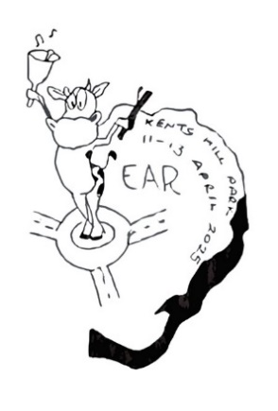**HRGB National Rally**

**Milton Keynes 2025**

**Feedback Form**

Please rate the following from 1 to 5 where 1 is very poor and 5 is very good by circling the appropriate number and provide any comment.

**Booking**

|  |  |  |  |  |  |
| --- | --- | --- | --- | --- | --- |
| Ease of accessing the booking form | **1** | **2** | **3** | **4** | **5** |
| Ease of completing the booking form | **1** | **2** | **3** | **4** | **5** |

Comments

**Pre-arrival Information**

|  |  |  |  |  |  |
| --- | --- | --- | --- | --- | --- |
| Quality of Pre-event information | **1** | **2** | **3** | **4** | **5** |

Comments

**Venue**

|  |  |  |  |  |  |
| --- | --- | --- | --- | --- | --- |
| Location | **1** | **2** | **3** | **4** | **5** |
| Overall impression of the venue | **1** | **2** | **3** | **4** | **5** |
| Suitability for future handbell events | **1** | **2** | **3** | **4** | **5** |

Comments

**Kents Hill Park Conference Centre** (this information will be passed to the venue in summary form)

|  |  |  |  |  |  |
| --- | --- | --- | --- | --- | --- |
| Location | **1** | **2** | **3** | **4** | **5** |
| Quality of bedrooms | **1** | **2** | **3** | **4** | **5** |
| Choice of food | **1** | **2** | **3** | **4** | **5** |
| Quality of food | **1** | **2** | **3** | **4** | **5** |
| Bar and Lounge facilities | **1** | **2** | **3** | **4** | **5** |
| Quality and facilities in Nightingale House | **1** | **2** | **3** | **4** | **5** |

Comments

**Workshops**

|  |  |  |  |  |  |
| --- | --- | --- | --- | --- | --- |
| Quality of information about the workshops | **1** | **2** | **3** | **4** | **5** |
| Ease of booking your workshops | **1** | **2** | **3** | **4** | **5** |
| Variety of workshops on offer | **1** | **2** | **3** | **4** | **5** |

Comments

**Evening Activities**

|  |  |  |  |  |  |
| --- | --- | --- | --- | --- | --- |
| The activities available on Friday evening | **1** | **2** | **3** | **4** | **5** |
| Showcase on Saturday evening | **1** | **2** | **3** | **4** | **5** |

Comments

**Massed Ringing on Sunday**

|  |  |  |  |  |  |
| --- | --- | --- | --- | --- | --- |
| Did you enjoy the massed ringing? | **1** | **2** | **3** | **4** | **5** |
| Choice of music | **1** | **2** | **3** | **4** | **5** |
| Time spent on each piece | **1** | **2** | **3** | **4** | **5** |

Comments

**Value for Money?**

|  |  |  |  |  |  |
| --- | --- | --- | --- | --- | --- |
| Rate the event in terms of value for money | **1** | **2** | **3** | **4** | **5** |

Comments

**Rating the event overall**

Did the rally meet, exceed or fall short of your expectations? In what way?

What did you enjoy most?

Was there anything you think could have been better?

Please give suggestions for improving the event in future years and any further comments

**Please return before you leave on Sunday or email to** [**2025rallyinfo@gmail.com**](mailto:2025rallyinfo@gmail.com) **by 30th April.**